Bitwise operators:

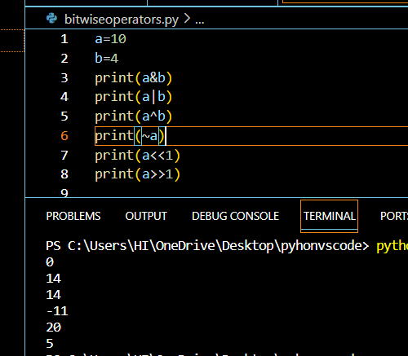

Leftshift:a<<n=a\*2^n

Right shift:a>>n=a/2^n

Logical operators:

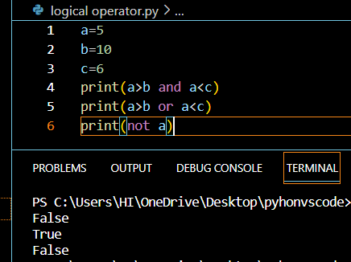

Loops:

For:

While:

Loop control statements:

Break: terminates the inner loop

Continue:skips the inner loop.

Pass:

Nested loops:

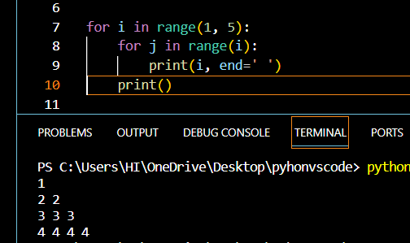

List:

Whileelse:

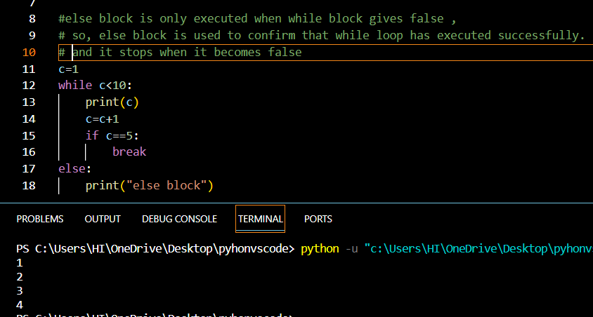

Is,isnot:

Convert decimal to binary:

